Utopia API Application Form
* 必填
* 灰色字體是提醒或範例，填寫時請將您的資料改成黑色字體
Utopia Application Form (Rev 0.1)
* Applicant | Wilson.chang | * Request Date | 2015/12/30
* Chip Name | Maserati | * Customer Name /Develop Name | 將與tee相關的 hdcp api從AESDMA module 移出獨立一包 library
* Module | Hdcp | * Please select below items:  Supernova Android □Mboot  □Others
*申請的API :
- [drvHDCP.h ] MS_BOOL MDrv_HDCP_HDCP14GetM0(MS_U8 u8PortIdx, MS_U8 *pu8Data);
- [drvHDCP.h ] MS_BOOL MDrv_HDCP_HDCP2Init(void);
- [drvHDCP.h ] MS_BOOL MDrv_HDCP_HDCP2TxEnableEncrypt(MS_U8 u8PortIdx, MS_BOOL bEnable);
- [drvHDCP.h ] MS_BOOL MDrv_HDCP_HDCP2TxFillCipherKey(MS_U8 u8PortIdx, MS_U8 *pu8Riv, MS_U8 *pu8ContentKey);
- [drvHDCP.h ] MS_BOOL MDrv_HDCP_HDCP2TxGetCipherState(MS_U8 u8PortIdx, MS_U8 *pu8State);
- [drvHDCP.h ] MS_BOOL MDrv_HDCP_HDCP2RxProcessCipher(MS_U8 u8PortIdx, MS_U8* pu8Riv, MS_U8 *pu8ContentKey);
- [drvHDCP.h ] MS_BOOL MDrv_HDCP_HDCP2RxGetCipherState(MS_U8 u8PortIdx, MS_U8 *pu8State);
*申請原由 :

將與tee相關的 hdcp api從AESDMA module 移出獨立一包 library

Application Flow
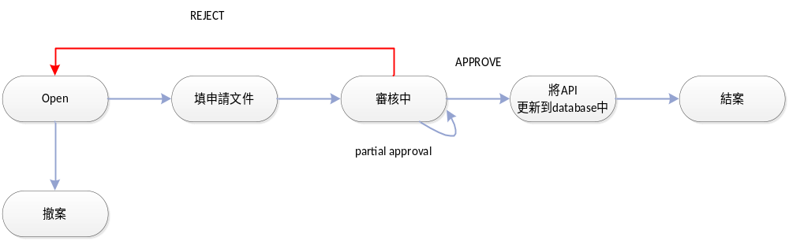

申請流程 :
Step1. 填寫申請文件並寄出
I.E- mail的格式
主旨: [OneUtopia] [Chip Name] [Module] API Application
Ex: [OneUtopia] Manhattan audio API Application

II.mail loop下面人員
收件者 :cc.chen@mstarsemi.com
副本 :dean.tseng@mstarsemi.com;;matt.sung@mstarsemi.com;kilroy.tseng@mstarsemi.com;luke.chiang@mstarsemi.com

III.如果有新增的API請在mail中提供API Specification
API Specification Sample參考:
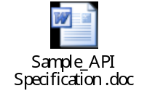

Step2.審核中
等待CC.chen審核

Step3. 將API更新到database中
當收到APPROVE後 我方會將會更新OneUtopia的database

Step4.結案
在下次utopia的release時
可以看到申請的API已經被APPROVE

